A Statement by the Catholic Bishops of New Jersey
On the 10th Anniversary of the Elimination of the Death Penalty in New Jersey

December 17, 2017

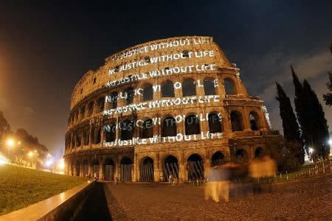
Over many decades, the Catholic Bishops of New Jersey consistently called for the abolishment of the death penalty. Thank God, on December 17, 2007, New Jersey became the first state in forty years to enact a law to eliminate the death penalty. Groups across the globe hailed the enactment of New Jersey’s law as a victory for the dignity of life. On December 19, 2007, the Colosseum in Rome glowed in New Jersey’s honor with the words “No Justice without Life.”

Our message is simple – every human being is made in the image and likeness of God, who alone is the absolute Lord of life from its beginning until its end (Genesis 1:26-28). The death penalty diminishes us as a society. We cannot teach respect for life by taking life.

We are not blind to the pain caused by crime. We acknowledge that all murders are violent and shocking; stirring emotions of revulsion and anger. We grieve for the victims. We are committed to comforting, assisting and praying for the families and friends of victims.

We affirm the state’s duty to punish criminals, to prevent crime, and to assist victims. We recognize the need to improve our criminal justice system and to forge a greater societal commitment to justice. However, we believe that society has effective ways to protect itself and to redress injustice without resorting to the use of the death penalty.

Today, on the 10th Anniversary of the elimination of the death penalty in New Jersey, we pray for an end to capital punishment in the 31 states that still have some form of capital punishment.

Cardinal Joseph A. Tobin, C.Ss.R.
Archbishop, Archdiocese of Newark

Most Reverend David M. O’Connell, C.M.
Bishop, Diocese of Trenton

Most Reverend Dennis J. Sullivan
Bishop, Diocese of Camden

Most Reverend Arthur J. Serratelli
Bishop, Diocese of Paterson

Most Reverend James F. Checchio
Bishop, Diocese of Metuchen

Most Reverend Kurt Burnette
Bishop, Byzantine Catholic Eparchy of Passaic

Most Reverend Yousif B. Habash
Bishop, Our Lady of Deliverance Syriac Catholic Diocese

Most Reverend Manuel A. Cruz, D.D.
Auxiliary Bishop, Archdiocese of Newark

